DAPP-III Coding Manual

Introduction to the Developmental Analysis of Psychotherapy Process (DAPP)
The Developmental Analysis of Psychotherapy Process method, first articulated in a coding manual in 2000, has been used to analyze and ultimately integrate the various processes through which development occurs within psychotherapy. Basseches’ and Mascolo’s (2010) book presents a thorough introduction to the theoretical assumptions, core concepts, methodological tools, and application to case material, of the DAPP approach to understanding psychotherapy process and outcome. Chapter 6, attached here as appendix A, describes in detail the suite of tools and methods of analysis that are referred to here as DAPP-II. DAPP-II has been used as a research tool for studying case material representing 14 different therapeutic approaches (see _____ for further details). In each case, DAPP-II has been used to rigorously track client development, and to identify common therapeutic resources used across approaches. Each analysis contributed to establishing the validity of DAPP as a useful framework for understanding psychotherapy as a unitary phenomenon; additionally, each analysis has produced clinically useful information. The following section will present fundamental concepts that are common across DAPP-II, and the new coding system emerging from this study, DAPP-III.
Core concepts in the Developmental Analysis of Psychotherapy Process
Underlying the DAPP framework are the following key assumptions: (a) that psychological development is a common outcome across all successful psychotherapy; (b) that the creation of the therapeutic relationship offers additional resources that may be effectively used within the clients’ developmental processes; and (c), when psychotherapy fails, the therapist provided resources which the client could not use and failed to provide resources that the client could use.
Psychological Development
In contrast to negative outcome measures such as symptom reduction, the DAPP framework allows for identification of a positive outcome in the form of developmental movement. By psychological development, we refer to clients’ transformations in cognitive and emotional organization that occur in the context of adaptation to the physical and social world. A DAPP analysis tracks as a client’s psychological schemas change from more global and undifferentiated states, to increasingly differentiated, integrated, and hierarchically integrated states (Basseches & Mascolo, 2011, pg. 14)
This process of development can be seen in one’s meaning-making and activity structures, or how one makes sense of and interacts with the world.
Basseches and Mascolo’s model of development also provides a method of tracking microdevelopmental movement, wherein development occurs in the context of mutual adaptation in which systems move from more global and undifferentiated states to increasingly more differentiated and integrated states. This is a reiterative process composed of three steps: differentiation, conflict, and synthesis. This process is tracked throughout DAPP analyses using codes for thesis, antithesis, conflict, and synthesis. A thesis is an expression of an element of action, experience or meaning, and its antithesis is an expression of differentiation or opposition from the thesis.
Conflict refers to the process of attending simultaneously to a thesis and its antithesis, and either one party or both parties in a therapeutic relationship can hold the conflict. It is similar to the Piagetian process in which differentiation increases disequilibrium and attention to the disequilibrium (or conflict) is necessary for equilibration to be achieved. This process is a continuous undercurrent throughout the developmental dialogue represented by therapy. Conflict occur exists whenever differentiated elements have not yet been integrated into a whole, and can range from being highly distressing or not distressing at all; thus an important aspect of DAPP coding involves selecting the most important conflicts.
A synthesis marks the resolution or transcending of the conflict through the emergence of a higher-order organization of activity and meaning-making. In Piagetian terms, synthesis can be thought of as an accommodation process that leads to an equilibration through the development of greater differentiation and complexity. It is through syntheses that we see the micro-development that results in the client being able to use more complex skills, or have more nuanced understandings, to more effectively interact with her life challenges.
On the flipside of psychological development, when a client is unable to grow in the face of conflict, we refer to the client as being stuck. This stuckness can be seen in psychotherapy when a client struggles to make use of therapeutic resources offered by the therapist, and there is a marked lack of synthetic understandings or actions. This can be due to the limitations of the context of psychotherapy, in that he distress or circumstances become so overwhelming that even with the additional resources offered by a therapist does not lead to the emergence of more adaptive, synthetic understandings or actions. Conversely, sometimes in the therapy session itself, the resources offered by the therapist are outside of the client’s capacity to make use of them. So while it is important to recognize the limited role of the psychotherapist, it is also important to recognize that sometimes a clinician is not meeting the client where she is at, developmentally. This ability of a client to use a resource that a therapist is offering, is what we refer to as attunement.
Therapeutic Resources
Beyond the identification of development, a DAPP analysis sheds light on the relational process by which such development is fostered. In a DAPP perspective, the role of the therapist is to offer additional resources to the client in order to facilitate novel understandings, experiences, and skills, which might ultimate lead to a more adaptive way of interacting in the world. These resources act as a sort of psychological scaffolding or guidance for the client as they learn new concepts. As a client develops in these areas, progressively less support is given in these areas, allowing the client to accomplish a task with minimal to no assistance.
The aforementioned resources provided by all psychotherapy comprise three overlapping but conceptually distinct relational processes: Attentional Support, Interpretation, and Enactment. Attentional support is the process by which a therapist facilitates the client’s fullest possible attention towards her activity, which comprises both outward behavior and inner meaning-making and experience. This can be achieved through direct methods, such as asking questions, encouraging the client to elaborate, acknowledging a client’s statement or experience, restating or reflecting, or offering the client feedback. Attentional support can also be offered through indirect methods such as offering reassurance or accurate empathy, sharing the burden of managing distressing emotions so that they can be shared and explored, or explicitly building the therapeutic alliance. Attentional support is primarily focused on maintaining or expanding the client’s awareness of actions, experiences and feelings, and does not entail explicit attempts by therapists to create new meanings or experiences as do the processes of interpretation and enactment, to be described next.
Interpretation is the relational process by which the therapist draws upon her own meaning-making structures to offer novel perspectives or meaning making experience. Interpretations can be in a specific form (e.g. when a therapist shares her perspective on why a client might behave in a certain way, or offer an alternative understanding of another person’s actions), or in a more general sense (e.g. during psychoeducation on the nature of anxiety, or normalizing a client’s experience of depression). Once an interpretation is offered for the client’s consideration, that interpretation then has the potentially to act as an antithesis for the client to incorporate into her own meaning-making structures, hopefully in the service of facilitating more adaptive understandings and skills.
Enactment is the final common resource, and refers to any processes within therapy in which novel experience or activity is evoked and then made a focus of exploration. The novel (and hopefully more adaptive) activities and experiences then serve as antitheses for a client to incorporate, potentially leading to the client’s development. Examples of enactment are when a therapist gives a client directions, homework, role-playing, or desensitizations/exposures. Additionally, meta-communication is a form of enactment, where the therapist explicitly points out the relational dynamics occurring in the moment. Enactment provides an avenue beyond intellectual understanding, facilitating experiential knowledge which can then be accommodated into the client’s schemas.
The therapeutic resources mentioned above can be found across psychotherapeutic approach, or further, in any helping relationship in which one or more parties assists in the learning of other parties (e.g. mentor relationships, teacher/pupil relationships, parent/child relationships, etc.) Further examples of each of the aforementioned resources can be found in reading the attached chapter from Basseches and Mascolo’s book (2011). All three resources can be found in varying levels according to therapeutic approach, or even individual clinician’s personality or therapy styles. They can be used in concert, or certain ones might be used more predominately at certain stages in the learning process. In addition to identifying the type of resource offered, a key component to a DAPP analysis is identifying whether or not the client is able to use those resources.
Level of Resource Usage
The following categories make up the coding for the client’s level of resource usage: use, qualify, consider, reject, avoid/ignore, and unknown. We can see a client use a resource that the therapist offers in many different ways. Examples of a client using a resource are when she answers a question, elaborates on a topic after a reflection or encouragement, agrees with an interpretation or incorporates an interpretation into her understanding, follows a therapist’s directions, or participates in a role play. When a client uses some aspect of the resource, but not fully, we code this as qualify. Examples of qualify are when a client accepts part of an interpretation but modifies or limits it in some way, or negotiates the terms of the novel action that the clinician suggests in the session or for homework. A client considers a resource when they express doubt or uncertainty about a resource (e.g. a question, interpretation, or suggestion for activity), but does not outright reject it. Examples of rejection are when a client declines to answer a question, denies the accuracy of an interpretation, or refuses to participate in a suggested activity. Avoid/Ignore is in a similar vein as rejection, except that in avoid/ignore, the client does not explicitly reject, but moves on as if the resource was not offered at all. Lastly, it is sometimes unclear at what level the client is or is not able to use a resource, resulting in the final category: unknown.
By examining the level of resource usage that a client demonstrates, a DAPP analysis can shed light on attunement between the client and therapist. It is unlikely that a therapist would be able to offer resources which a client is always able to use. However, it is necessary for that clinician to then be able to identify when a client is not able to use a resource, and then to adapt her further efforts in order to better meet the client where she is at in her developmental process. The potential difficulty of being attuned with clients with whom we are not on the same page, is what makes the exercise of identifying the level of resource usage so helpful. Once a clinician notices that the client is unable to fully use the offered resources, she might be more inclined to figure out what is getting in the way, and to adapt the resources being offered.
Sometimes the resources offered are not from therapist to client, but from client to therapist, or client to another client. These resources are also important to track, especially when these client-offered-resources can provide important feedback for the clinician in how to adapt. For example, a client might ask a clarifying question, make an interpretation about the clinician, or elicit novel interacting from the clinician. In this way, it is important to recognize that while the clinician is in the helping position, the client can be a powerful source contributing to the clinician’s development.
How to Conduct a DAPP-III Analysis
Choosing the Data
One of the most important aspects of a DAPP analysis is in the selection of data to analyze. First and foremost, it can be difficult to gain access of video or audio recorded psychotherapy sessions. However, there are sources that can be found through APA, or most libraries, which provide such videos upon request. Furthermore, it can be especially powerful for a therapist to use his or her own sessions as a way to deeply reflect. Of course, this would require consent by the client in order to audio/video tape the sessions, which would need to be negotiated on a case to case basis. Finally, transcripts can be generated by the participating clinicians through role plays recreating scenarios experienced in sessions, or even ones that one could imagine or anticipate.
The selection of data is perhaps the most important part of the process, as it is the data which will drive what is gleaned. The ideal data to be working with then, would be one’s own sessions, followed by real psychotherapy sessions conducted by other clinicians, and lastly, through made up scenarios. Of course, the ease-of-access to these forms of data are reversely correlated with the desirability of such data, which points to the main advantage of constructing the data. Despite an imaginary scenario not being grounded in real situations, it still provides an avenue for practicing and learning the coding system. Because DAPP-III is a clinical training tool as opposed to a research tool, it is through learning how to code and apply the concepts of DAPP which provide the most benefit, as opposed to the coded transcripts themselves; in learning how to use DAPP-III, the process is the product.
The criteria for choosing sections of sessions for which to code can vary depending on the purpose of what one hopes to learn and/or achieve. If one wants to focus on further understanding what psychological development looks like, it is beneficial to consider sections wherein clients seem to show transformations or change, the stages leading up to the aforementioned transformations/change, or perhaps more importantly, when clients appear to be stuck. While it is important to be able to document when psychotherapy is successful, it is as important, if not more so, to be able to identify when and how therapy is not successful. Thus, sections in which it is unclear whether the client is progressing, or where it is clear that he or she is struggling, are ripe for DAPP analyses.
Preparing the Transcripts
Once a section of a therapy session has been selected, it must be transcribed. This can be done manually, or with transcription software. Each exchange of speech between participants is considered an “utterance,” and should begin on a new line with an identifier. The identifiers can be pseudonyms, initials, or simply “client” and “therapist.” The transcript can then be transferred to a spreadsheet (e.g. Google Spreadsheet ©, Excel ©, or WordPerfect ©). The spreadsheet program should provide numbering for each of the lines, which is helpful for keeping track in the coding of conflicts and syntheses.
The first column of the spreadsheet consist of the utterances from the transcript. The following four columns are: Conflict/Synthesis, Resource Offered, Resource Usage, and Coder Rationale. A sample of the coding structure is provided below in Table 1. It is helpful to freeze the top row, so that you can continue to read the columns while scrolling through your transcript.
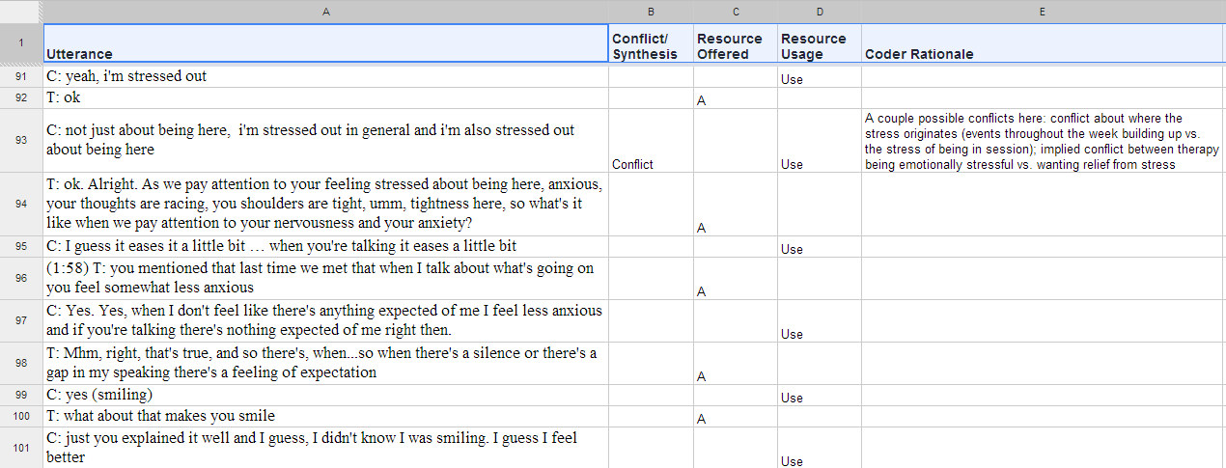
It is important to recognize that while there is a prescribed structure for DAPP-III coding, that it is flexible for fitting the needs of an analysis. For example, in the example of coding provided above, you may notice that there are non-verbal descriptions, as well as an extended pause, documented in parentheses. Additionally, coding can be done between dyads, such as in individual psychotherapy, or between multiple parties, such as couples or group therapy (an example of which is in Table 2).
Through the preparation of the transcript for coding, you should gain a sense of familiarity with the session. If the transcript has already been prepared, then it is helpful to first read through the session, so that you have an idea of where the most eventful moments occur.
Coding the Transcripts
After the preparation or read-through, the next step is to code the conflicts and syntheses. A conflict may be interpersonal, intrapersonal, or between the client and her environment. For example, the conflict in the transcript presented in Table 1 represents potential conflict on multiple levels. During this process, it is important to record the rationale behind the ascribed codes, for which the Coder Rationale section is provided. It can be useful to provide the utterance numbers, if there is a conflict between specific utterances; this can be recorded with “<C>” inserted between the numbers of the two conflicting utterances, as demonstrated in Table 2. Additionally, if possible when coding syntheses, you can identify the specific conflicts synthesized.
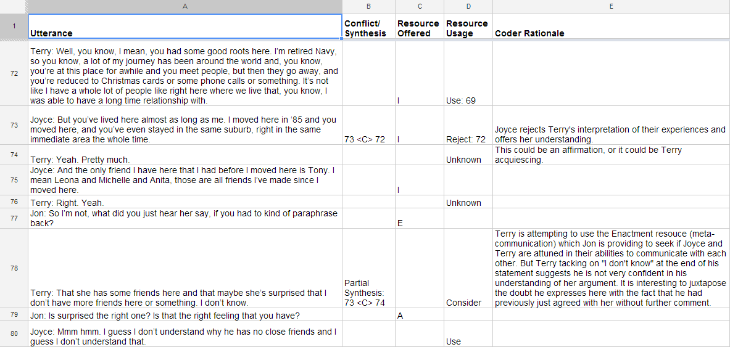
Once the conflicts have been identified, the next step is to identify which resources the therapist (or client) offers, and to what level the client (or therapist) is able to use those resources. In the first example (Table 1), we saw that the client was able to use the resources effectively. However, in the second example (Table 2), it was less clear whether the client (Terry) was fully able use the resources provided.
In conducting a DAPP-III analysis, the most important aspect of the coding process is in documenting the Coder Rationale. It is through the explication of the coding judgments which elicit our assumptions about what is happening in the session. Through an increased focus of exchanges on the micro-level of a psychotherapy session, we are given an opportunity to reflect on a number of levels: 1) the fundamental change mechanisms involved in fostering development in the context of psychotherapy; 2) identifying whether we can see if a client is making progress or not; and 3), if the client is stuck, whether the therapist adapts to the client in order to provide resources that the client can use more effectively. By recording the rationale behind the codes, coders can then share with others their respective coding, which opens their understandings up for input from others. This exchange of ideas and understandings allow for intersubjective reflections, and expand perspectives on the change process.
Even though the new DAPP-III coding system is more accessible than DAPP-II, the fact is that any DAPP coding requires verbatim material which clinicians usually do not have. Therefore, the main way in which DAPP-III can be used by clinicians to improve practice is by using the DAPP framework as a heuristic. Doing so entails asking the following questions regarding the specific case being considered:
1. What are the conflicts brought to or emerging in therapy?
2. Is there visible progress towards synthesizing those conflicts?
3. What resources are offered to the client?
4. Which resources has the client been using? Which have been less helpful?
5. What evidence is there to support the answers to the previous questions?
6. How can attunement be increased in the resources offered?
The above heuristic questions are fostered first through learning how to use the DAPP-III coding system, and then further reinforced through guided DAPP discussions. By opening the coders’ judgment processes to multiple perspectives, collaborative critical thinking about psychotherapy is facilitated.

